**CHAPTER I**

**INTRODUCTION**

* 1. **Background of the Study**

Monitoring has been the essential way of observing the subjects and recording the gathered data. It plays the vital role in project planning and implementation hence; it provides information that will be the basis for further study. In the past, to monitor the subject means to constantly check it manually. Now, as the technology advances, different monitoring system or what is commonly known as data logger has now been widely used wherein it obliterated the tiresome routine of gathering data.

Data logger is an electronic device that automatically gathers analog data such as temperature and humidity. With the aid of sensors, the analog output is now convertible to a digital output. Various data loggers have been introduced continuously such as Bluetooth Data Logger, Web-based Data Logging System, Stand-alone USB Data Loggers and Wireless Data Nodes. Also, in choosing a data logger, there are some parameters that should be considered as well such as input signals, number of signals, size, memory/speed and lastly, real time operation.

* 1. **Statement of the Problem**

In healthcare, data gathering is manual and repetitive. There may be available data loggers and monitors yet, they are expensive and cannot be procured easily. Several data loggers have fixed interval of data acquisition and don’t have a network for data storage. Also, most data loggers available in the market don’t have a power management system. Hence, this paper aims to design a wireless and mobile multi-node data logging platform that reads human temperature and pulse rate.

* 1. **Objectives of the Study**

Generally, the main objective of this study is to construct a prototype of a wireless multi-node data logger that has mobile sensor nodes using transceivers that communicate in the ISM band.

The following are the specific objectives of this study:

1. To construct a wearable data logger platform.
2. To utilize the CC1101 transceiver chips for communication.
3. To attach a temperature and pulse rate sensor in the data logger platform for monitoring human body temperature and pulse rate.
4. To identify a suitable location for human body temperature and pulse rate monitoring.
   1. **Significance of the study**

This project aims to construct a wearable data logger platform that can assist any health center to monitor and gather the temperature and pulse rate of a mobile patient, wirelessly. This projects offers a rechargeable battery since most data loggers are battery powered that has a limited life expectancy depending on a number of parameters and the sample rate. Hence, the accessibility and flexibility to conduct further study can now be easily attained.

* 1. **Scope and Limitation of the Study**

This project is limited only to the construction of a two-way wireless data logger prototype and it aims to read temperature and pulse rate only. This project is also limited in constructing three sensor nodes only.

* 1. **Definition of Terms**

**ATmega328P –** a single chip microcontroller created by Atmel and belongs to the megaAVR series. It is commonly used in many projects and autonomous systems where a simple, low-powered, low cost microcontroller is needed. Thus, the most common implementation of this chip is on the ever popular Arduino development platform.

**Bootloader –** a computer program that loads on operating system or some other system software for the computer after completion of the power-on-self-test. It is basically package of instructions to boot OS kernel and most of them also have their own debugging or modification environment. Thus bootloader allows installing new firmware using an external programmer.

**Data Logger –** a data acquisition device that takes readings at a pre-set interval and stores them away in their internal memory for download later. It helps find the answers to questions regarding accountability, efficiency, quality and liability by collecting data over an extended period of time with a high degree of accuracy. They expose information that often revealing and cannot be found easily by other means.

**Data Acquisition –** the process of measuring an electrical or physical phenomenon such as voltage, current, temperature, pressure, or sound with a computer. A DAQ system consists of sensors, DAQ measurement hardware, and a computer with programmable software

**Platform –** is a system that consists of a hardware device and an operating system that an application, program or process runs upon.

**Pulse rate** – is a measurement of the heart rate, or the number of times the heart beats per minute.

**Sensor** – is device that detects events or changes in quantities and provides a corresponding output generally as an electrical or optical signal.

**Thermometer** – is a device that measures temperature or a temperature gradient using a variety of different principles. A thermometer has two (2) important elements: the temperature sensor in which some physical change occurs with temperature, plus some means of converting this physical change into a numerical value.

**Wireless Sensor** – is a standard measurement tools equipped with transmitter to convert signals from process control instruments into a radio transmission. The radio signal is interpreted by a receiver which then converts the wireless signal to a specific, desired output such as an analog current or data analysis via computer software.

* 1. **Theoretical Framework**

**1.7.1 Arduino**

Arduino is an open-source hardware/software electronic board. It consists of both a physical programmable circuit board, denoted as microcontroller and a software or Integrated Development Environment (IDE). IDE, which runs in the computer, is used to write and upload program that will interact with the board and the devices connected to it. Apart from being an open-source, Arduino is an extensible prototyping cross-platform which implies that other skilled circuit designers can modify and make their own version of the module resulting to extension and innovations. (Arduino, 2016)

**1.7.1.a Hardware**

The Arduino board is a small-form microcontroller circuit board. Nowadays, a number of Arduino board has been introduced and one of these is the Arduino Uno, shown in figure 1.1. Arduino board reads analog inputs from sensors and actuators and converts it to digital output. Unlike any other programmable circuit boards, Arduino will run continuously from a powered USB port and the set of instructions or computer code will be loaded onto the microcontroller on the board through USB connection. To do so, the use of the Arduino programming language, based on wiring, and the use of the Arduino Software (IDE), based on the processing, will be instigated. Arduino has the ability to interact with the outside world through its 14 digital I/O pins labeled 0 to 13. Each digital pin can sink or source about 40mA. Note that the power source should not be greater than 20 Volts to prevent damage in Arduino. Recommended voltage for most Arduino models is in the range of 6 to 12 Volts. (What is an Arduino, 2014)

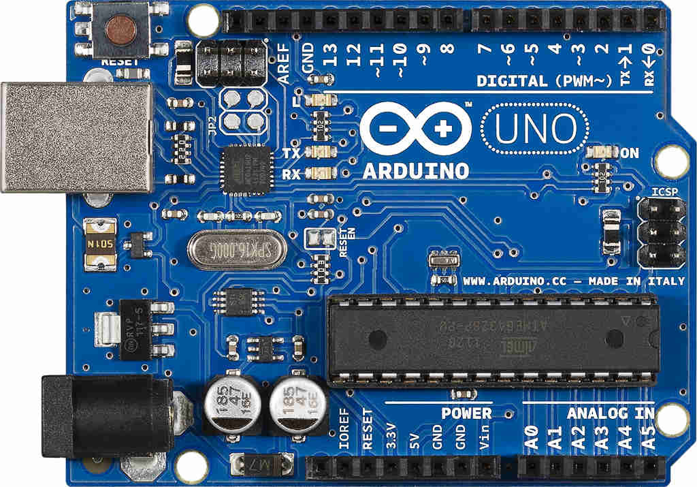

**Figure 1.1** Arduino UNO (Arduino Uno R3, 2016)

**1.7.1.b Software**

The IDE is the front end of Arduino which uses a C/C++ derived programming language that is actually based on Processing. Programs written using IDE are called sketches. These sketches are written in the text editor and are saved with the file extension .ino. It has features for cutting and pasting and replacing text and search engine as well. In figure 1.2, it shows that IDE window with toolbar buttons that allows to programmer to create, open, verify, upload and save sketches and also open the serial monitor. The message area gives feedback while saving, exporting and displaying errors. The console displays text output including complete error messages and such. The bottom right hand corner of the window displays the processes in the selected serial port for an Arduino. (Arduino Software (IDE), 2015)

Code in every sketch must be entered in the proper syntax, in other words, the use of valid command names and a valid grammar for each code line must be applied. (Brooks, 2016)

Arduino IDE communicates with the board through the USB-to-Serial chip that sends the new sketches to the chip. IDE will then open a serial port and communicates with the bootloader.

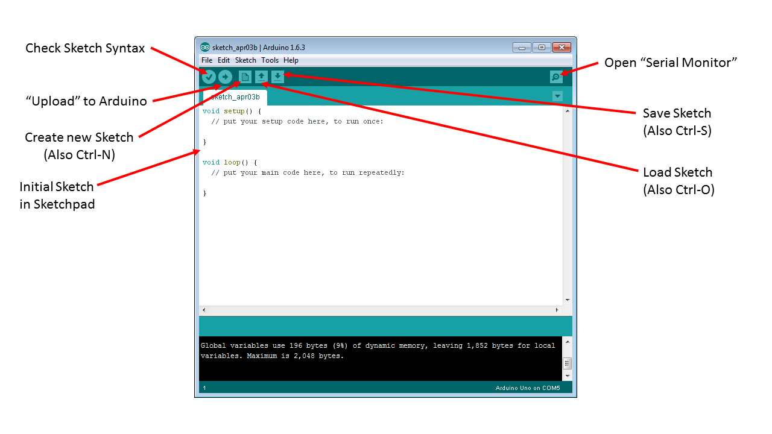

**Figure 1.2** IDE Window (Predko, 2015)

**1.7.2 MLX90614 – Infrared Thermometer**

Melexis’ MLX90614 is an infrared thermometer designed for non-contact temperature sensing. This infrared thermometer varies by supplied voltage, A – 5V and B – 3V, number of IR thermopiles and whether they filter inside or outside the sensor. It has a low noise amplifier, high resolution 17-bit ADC and powerful DSP unit, a high accuracy and resolution of the thermometer are achieved. (MLX90614 IR Thermometer Hookup Guide, 2014)

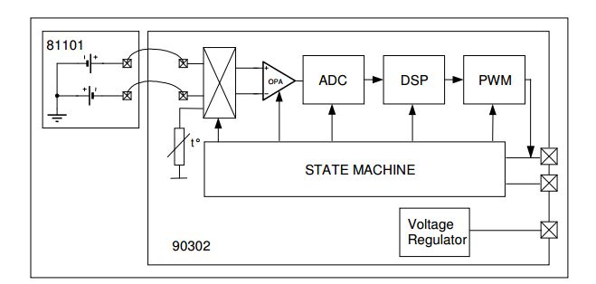

**Figure 1.3 MLX90614 Block Diagram** (MLX90614 IR Thermometer Hookup Guide, 2014)

MLX90614 produces two temperature measurements: an object and an ambient reading. The object reading is the non-contact measurement from the sensor while the ambient temperature measures the temperature on the die of the sensor. Although the ambient readings can be useful to calibrate the data but the readings from the object temperature will be used as the core of the data. In figure 1.5, the operation of the MLX90614 is controlled by an internal state machine. This state machine controls the measurements and calculations of the object and ambient temperatures and does the post-processing of the temperatures to output them through PWM output or SMBus compatible interface. (MLX90614 IR Thermometer Hookup Guide, 2014)

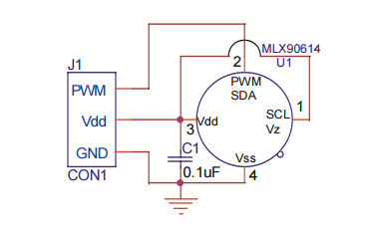

**Figure 1.4 MLX90614 connection to PWM** (MLX90614 family, 2013)

In figures 1.4 and 1.5, it shows the connections of MLX90614 to PWM and SMBus. The thermometer is a factory-calibrated with a digital System Management Bus (SMBus) output giving full access to the readings in the complete temperature ranges with an output resolution of 0.02 °C. Also, digital output can be configured to 10-bit Pulse Width Modulation (PWM) and continuously transmits the temperature readings in range of -20 to 120 °C with an output resolution of 0.14 °C. ()

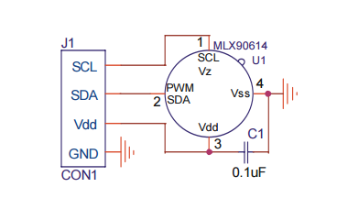

**Figure 1.5 MLX90614 connections to SMBus** (MLX90614 family, 2013)

**1.7.3 CC1101**

CC1101 is a low-cost sub-1 GHz transceiver for very low-power wireless applications. The circuit is intended for the ISM (Industrial, Scientific and Medical) and SRD (Short Range Device) frequency bands at 315, 433, 868 and 915 MHz, but can be easily programmed for operation at other frequencies in the 300-348 MHz, 387-464 MHz and 779-928 MHz band. The RF transceiver is integrated with a highly configurable baseband modem. The modem supports various modulation formats and has a configurable data rate up to 600 kbps.

CC1101 also provides extensive hardware support for packet handling, data buffering, burst transmission, clear channel assessment, link quality indication and wake-on-radio. The main operating parameters and the 64-byte transmit/receive FIFOs of CC1101 can be controlled via an SPI interface. (CC1101, 1995)

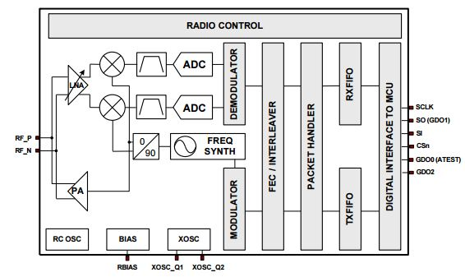

**Figure 1.6 CC1101 Block Diagram** (CC1101, 2015)

A simplified block diagram of CC1101 is shown in figure 1.6. CC1101 features a low-IF receiver in which the received RF signal is amplified by the low-noise amplifier (LNA) and down-converted in quadrature (I and Q) to the intermediate frequency (IF). At IF, I/Q signals are digitizes by the ADCs and performs automatic gain control (AGC), fine channel filtering, demodulation and bit/packet synchronization, digitally. The transmitter part is based on direct synthesis of the RF frequency. The frequency synthesizer includes a completely on-chip LC VCO and a 90 degree phase to the down-conversion mixers in receive mode. (CC1101, 2015)

**1.7.4 Grove Ear-clip Heart Rate Sensor**

The Heart Rate clip kit contains an ear clip and a receiver module. The ear clip sensor is very sensitive and the receiver module uses very little proper. It has a low power consumption and a wide power supply ranging from 3-5V. (Grove - Ear-clip Heart Rate Sensor, 2014)

**1.7.5 ATmega328p**

Atmega328p is a The high-performance Atmel picoPower 8-bit AVR RISC-based microcontroller combines 32KB ISP flash memory with read-while-write capabilities, 1024B EEPROM, 2KB SRAM, 23 general purpose I/O lines, 32 general purpose working registers, three flexible timer/counters with compare modes, internal and external interrupts, serial programmable USART, a byte-oriented 2-wire serial interface, SPI serial port, a 6-channel 10-bit A/D converter (8-channels in TQFP and QFN/MLF packages), programmable watchdog timer with internal oscillator, and five software selectable power saving modes. The device operates between 1.8-5.5 volts. By executing powerful instructions in a single clock cycle, the device achieves throughputs approaching 1 MIPS per MHz, balancing power consumption and processing speed. (ATMEL 8-Bit Microcontroller Datasheet, 2015)

**1.7.6 ADP1621**

The ADP1621 is a fixed-frequency, PWM, current-mode, step-up converter controller. It drives an external n-channel MOSFET to convert the input voltage to a higher output voltage. It is used to drive flyback, SEPIC and forward converter topologies, either isolated or non-isolated. ADP1621 eliminates the use of current-sense power resistor by measuring the voltage drop across the on resistance of the n-channel MOSFET. With that, it allows up to a maximum voltage of 30V at the switch node, maximizes efficiency and reduces cost. (ADP1621, 2006)